­­­Programming project

Look up a word, learn it forever.

A fruitful website: <https://www.vocabulary.com/play/>

* Crash course in javascript
* Javascript 🡪 respond to different inputs from user
* Use package managers (they may help but don’t depend on them BECAUSE YOUR PURPOSE IS TO LEARN)
* Choose colors based on the psychology of colors
* Revise the html course

ideas

* choose a theme for each unit (picture or color)
* take the advice of miss Mai
* characters that appear in each lesson
* created by Mennatullah Ahmed| All Rights Reserved
* leave your opinion part
* think of the website’s name
* choose a slogan or a quote for the website
* About us
* FAQs (what is the purpose of the website – how to use this website efficiently )
* Certificate
* REAL SAT AND EST QUESTIONS
* Description of the lesson – time needed to study
* Schedules to finish studying (flash schedule – average schedule – busy schedule)
* A story – article – a part of an SAT passage per week written about the origin of a word OR using the words of a lesson
* Choose a path (nerd student – SAT hacker)
* Stats like that in the touch typing website (to know the code🡪 write click inspect)
* Leaderboard (<https://www.vocabulary.com/leaderboards/thisweek/> )

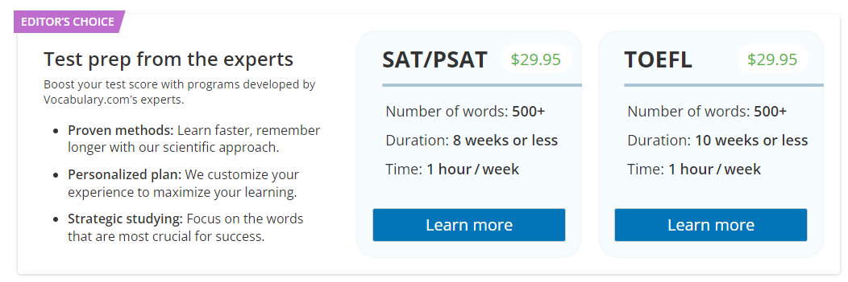

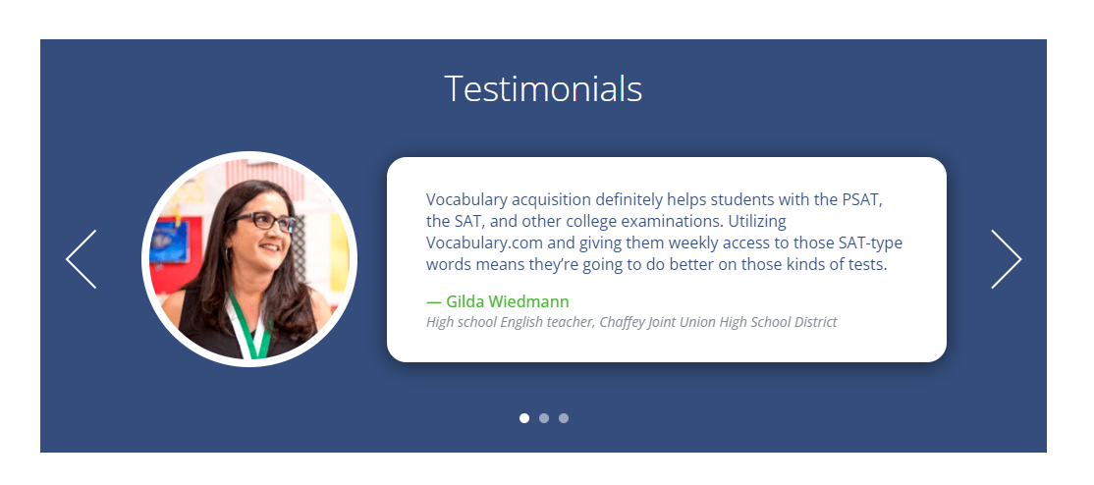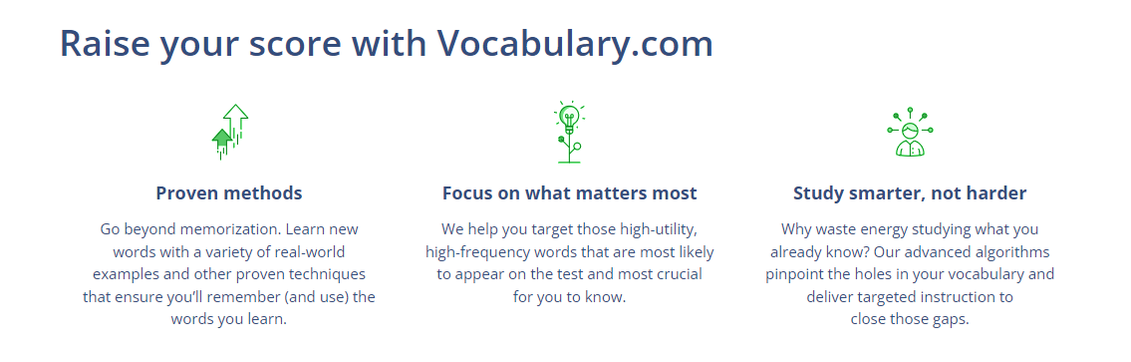

Features

* Responsiveness
* Test prep
* Commonly confusing words
* Words with preposition
* Accessibility to colorblind
* Accessible to people with special needs
* NOT divided by alphabetic order (بيلغبط)
* Questions: complete – choose (problem means: mama – papa – gown – difficulty)

Tips

* Don’t settle on the first color palette that you choose TEST IT WITH USERS
* Keep yourself to a color or two so that people associate it with your product

Color

* Avoid over simulation and lack of simulation
* Subtle, cool and warm colors, on the other hand, are better for middle and high schools
* Maximum three to five colors (three is preferable) (1-2 🡪 bold striking colors that are related to the brand | 1-2 🡪 neutral colors | 1🡪 very strong contrasting color to grab attention)
* Coolers website: <https://coolors.co/>
* Color psychology
* Color culture
* Semantic colors (standard)
* For inbody text use black or dark shades od gray

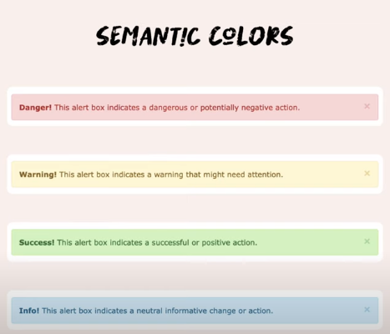

* **I mostly go for BLUE**
* **Red**: Stimulant; provokes conversation; improves performance/concentration; spurs action.
* **Orange:** Uplifting; stimulates critical thinking and memorization; increases appetite.
* **Yellow:** Promotes awareness; helps to release serotonin for happy mood.
* **Green:** Calming effect; stress reliever; promotes concentration
* **Blue:** Enhances creativity and alertness; promotes tranquility; improves overall health, memory, and mood; lessens fatigue and depression.
* **Violet**: Represents wisdom and authority; respectful.
* **Pink:**Soothing; reduces heart rate; energizing effect (with saturated shades) or comforting effect (with paler shades).
* **Black:** Promotes sophistication, security, and efficiency; the absence of color.
* **White:** Conveys sterility, simplicity, clarity, and purity; hygienic.

Good websites references

<https://www.cambly.com/en/tutors?lang=en>

<https://www.skimatalk.com/en> (good in the why and about)

<https://www.amigosingleses.com/> (good reference; specially that we have same color palettes)

<https://www.rosettastone.com/?prid=livemocha_com> PERFECT DESIGNN

**IMPORTANT LINKS FROM ELZERO WEBSCHOOL**

Template1:

* most important vedio: vedio no2: create container and add font icons

<https://www.youtube.com/watch?v=7_USXxmn7DM&list=PLDoPjvoNmBAy1l-2A21ng3gxEyocruT0t>

Template2:

<https://www.youtube.com/watch?v=7_USXxmn7DM&list=PLDoPjvoNmBAy1l-2A21ng3gxEyocruT0t>

Template3:

<https://www.youtube.com/watch?v=lXVP3rDH9EU&list=PLDoPjvoNmBAxuCSp2_-9LurPqRVwketnc>

Template with HTML, JAVA AND CSS:

<https://www.youtube.com/watch?v=vedT2jk3hi4&list=PLDoPjvoNmBAzvmpzF-6l3tAviiCPbwkB8>

CSS COURSE:

<https://www.youtube.com/watch?v=MBq8ZFEIIaQ&list=PLDoPjvoNmBAzHSjcR-HnW9tnxyuye8KbF>

what will I write in the steps (journey) presentation:

* Learning touch typing
* Taking the html course

The plan and their deadline:

* Css (deadline: Monday)
* Watch and tanfeez template 2 (deadline: Thursday)
* Jquery or javascript crash course (deadline: sunday)

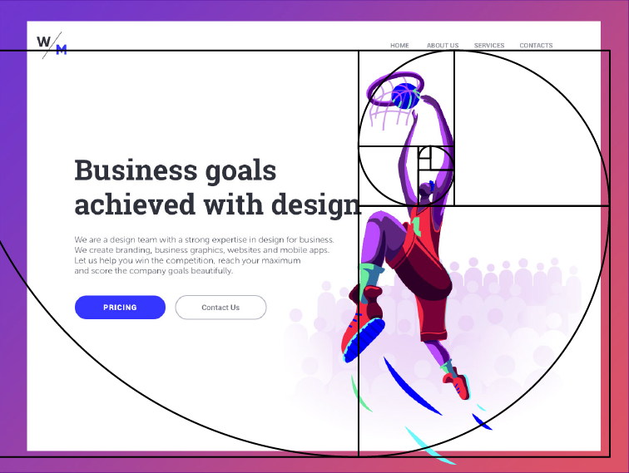

Applications downloaded for inspiration:

* Memrise (use memes and reels to memorize words)
* Quizlet (useful for memorizing words specially for tests)

Suggested names for the website

* Satvoc

Websites for illustration:

* Freepik